Reception and admin assistant  Southwark Inclusive Learning Service (SILS)  Dates: Apply by Friday 13th October 2017,  Starting 1st November 2017  Salary: £17,995 to £18,545  Contract term: Fixed Term; for 1 year initially  Hours: Full time 36 hours per week, 39 weeks, term time only | 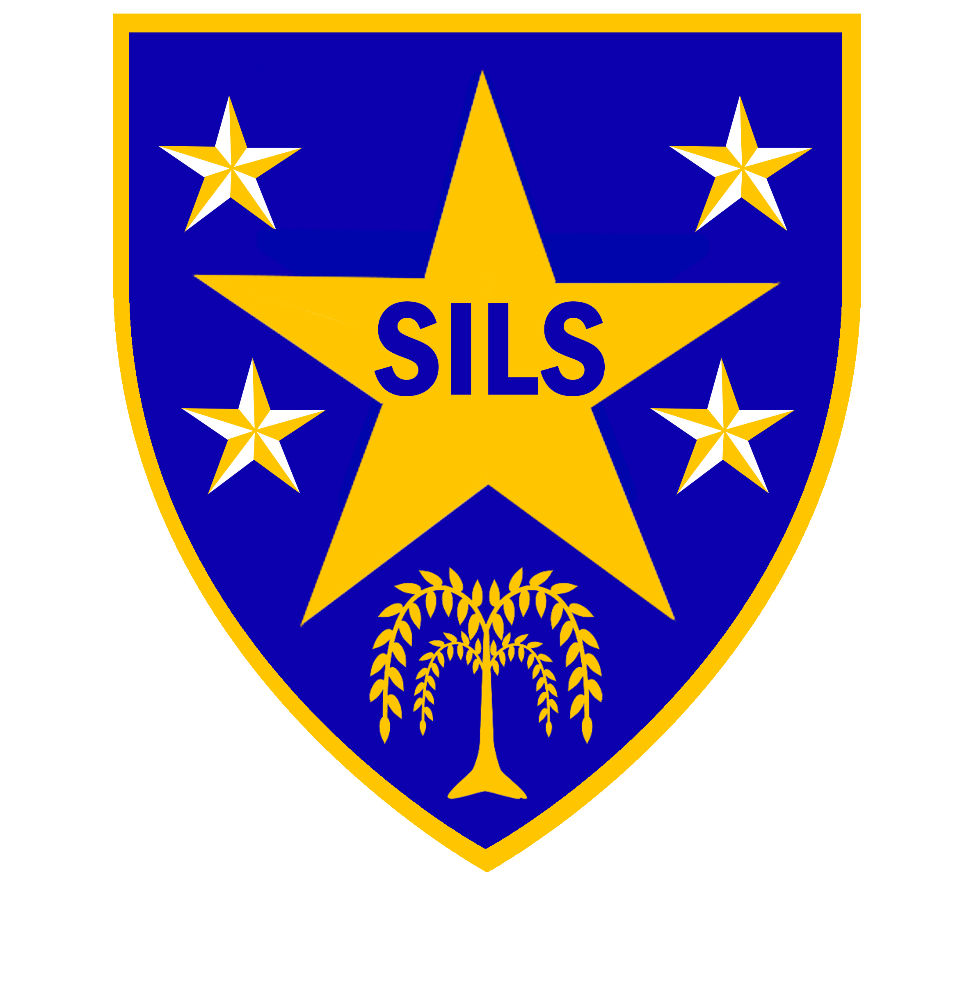

Southwark Inclusive Learning Service (SILS) is an alternative education school for 11-16 year olds excluded from mainstream schools largely because of their social emotional or mental health difficulties. SILS has consistently been judged to be a ‘Good School’ (Ofsted, 2012 & 2015) and all the staff at the school are committed to achieving the best outcomes for our learners.

The role
We are seeking an enthusiastic, organised and efficient admin professional to assist with the smooth running of the school office at our key stage 4 London Bridge site.
The successful candidate must have previous clerical / admin experience. They must also have good communication, literacy and ICT skills, and they will be expected to work calmly and efficiently under pressure.
A good understanding of the demands of work within an educational setting is desirable. As well as a good knowledge of SIMS and a sense of humour. We are particularly keen to hear from those with a background of work with young people and their families.
Although the vacancy is based at key stage 4, interested applicants must be willing to work effectively across our two sites (Porlock Street SE1 and Davey Street SE15).
Interested? Please have a read through the job description and application form which is available on the school's website www.silsschools.org under Job Vacancies, and do note that only applications submitted on the school's form will be considered.

Closing date: Friday 13th October 2017, 12.00 noon
Interviews: Week beginning 16th October 2017

Enquiries: Carol Hepper, Business Manager on 0207 525 1668, email carol.hepper@southwark.gov.uk

Address: Southwark Inclusive Learning Service
2 Davey Street, London. SE15 6LF. Tel: 0207 525 1150

SILS is committed to safeguarding and promoting the welfare of children and young people and expects all staff to share this commitment; therefore the successful applicant will be required to undertake an enhanced Disclosure and Barring Service Check via the DBS.

