Vacancy: Teacher of Science /Biology (part time)  Dates: Apply by 22/ 06/ 2018; To start 1st Sept 2018  Salary: MPS + SEN1  Location: South London  Contract type: Part time 0.6 FTE  Contract term: Fixed term one year | 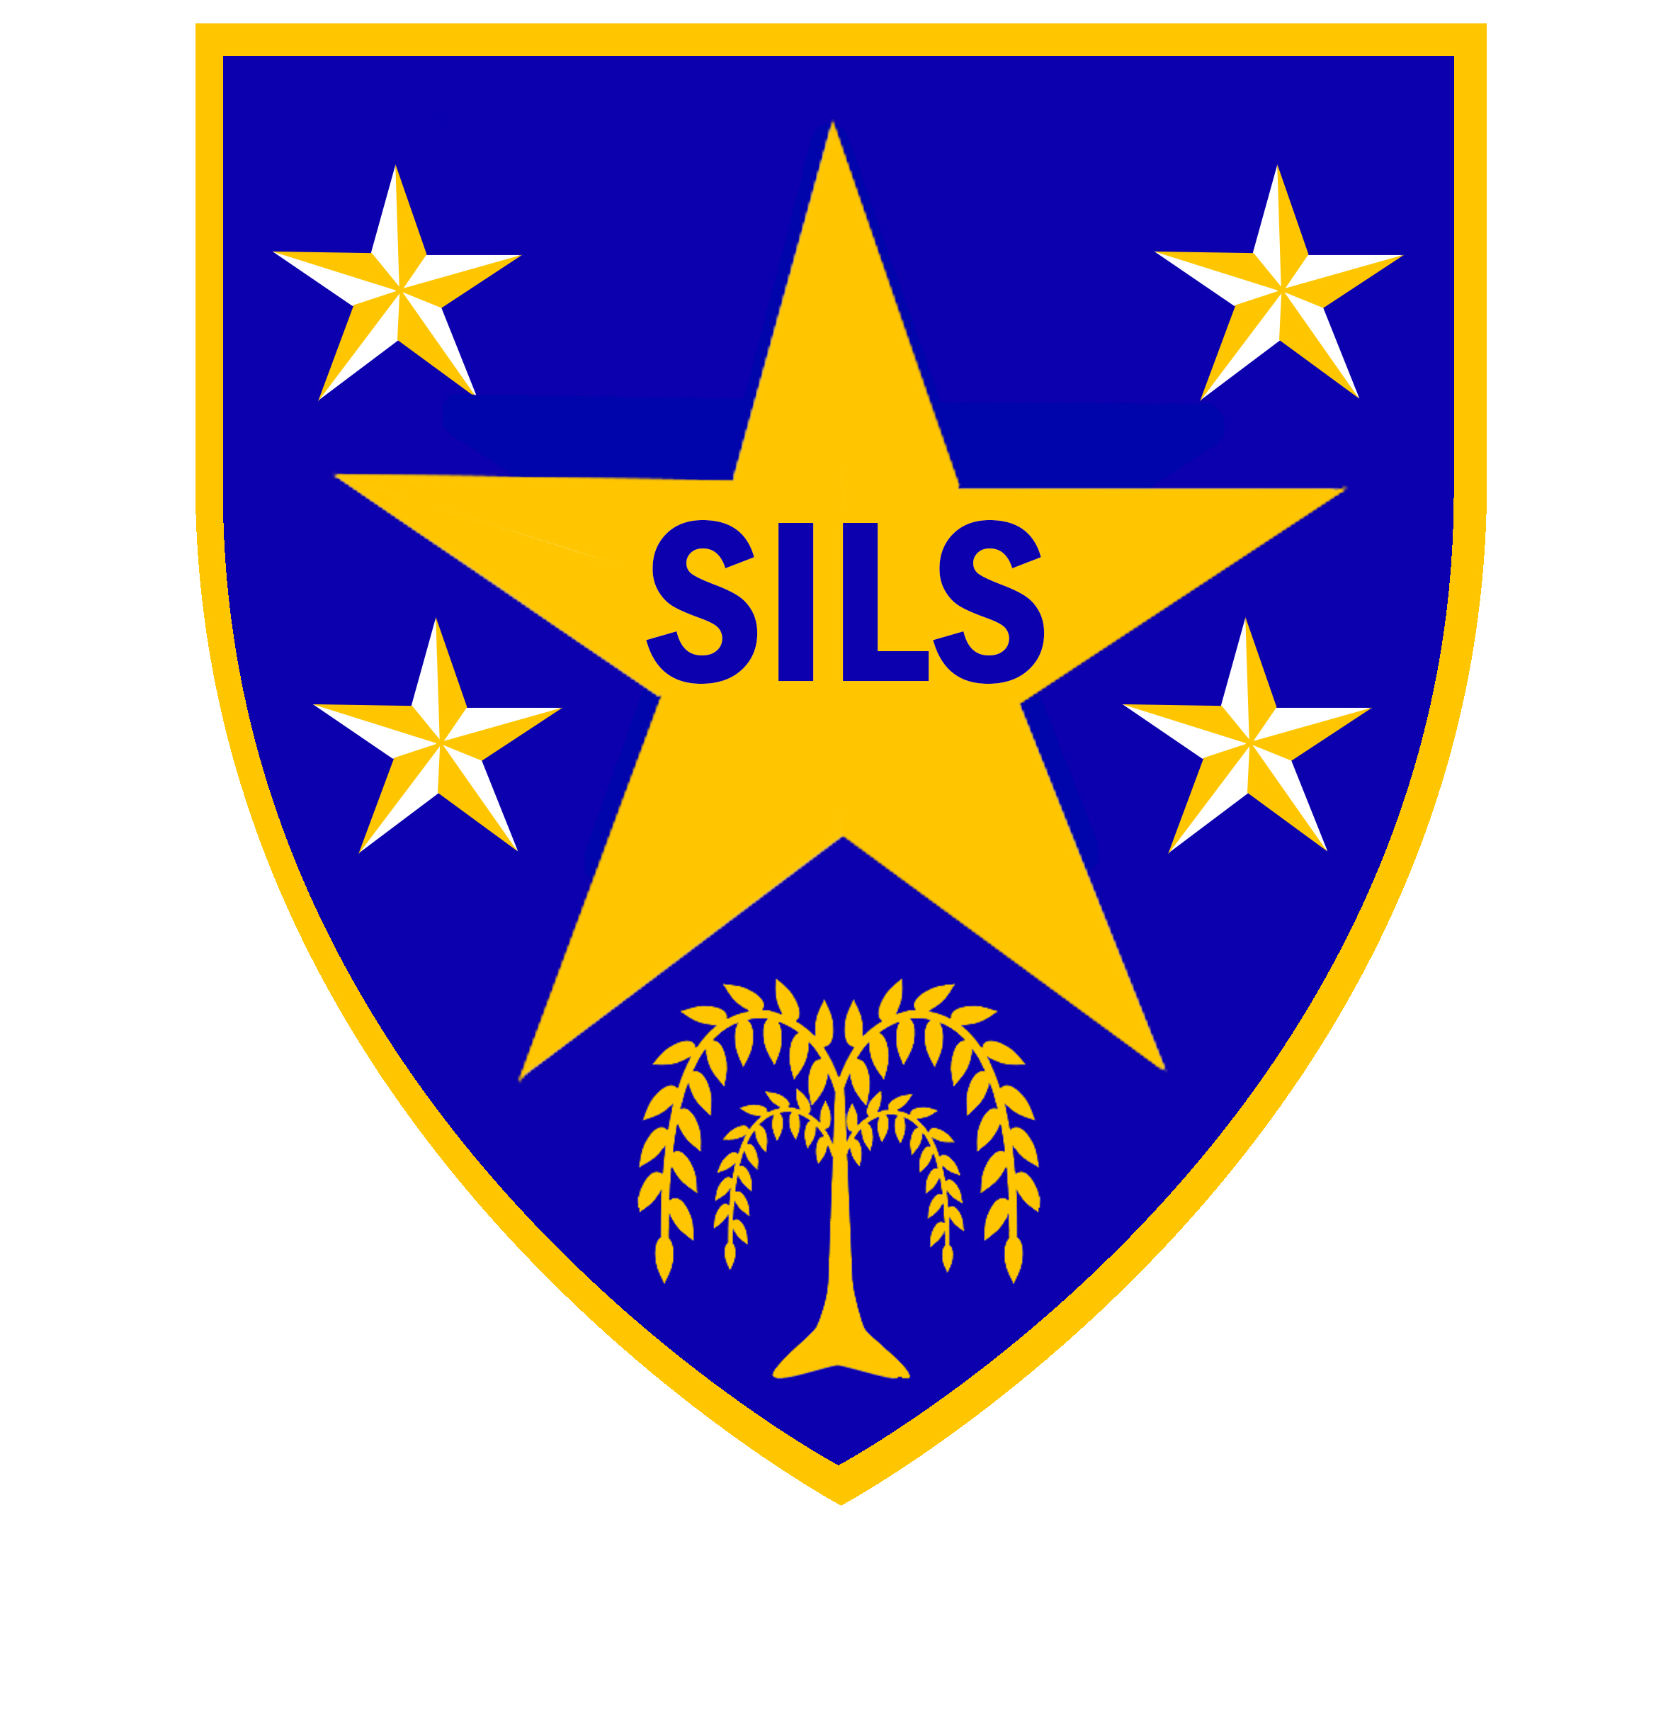
SILS is an alternative education provision for secondary aged learners who are out of mainstream school because of social, emotional, behaviour and / or mental health needs (SEMH).
Every member of the SILS community is valued, and our ideal candidate for this position will have strong experience of motivating and engaging learners who may be disengaged or have additional needs.
We are a ‘Good School’, and our ‘staff work collaboratively to give every student the chance to succeed’ (Ofsted 2015).

The role – part time teacher of science
We are seeking to appoint an enthusiastic and inspirational teacher to lead the delivery of Science, with specific focus on human biology at KS4.
As lead professional, the successful candidate must have a passion for Science and will be responsible for the design and implementation of a fun relevant and engaging curriculum.
As Science is being reintroduced to the SILS curriculum, we need an experienced innovative professional to deliver stimulating lessons, which will lead to the achievement of appropriate qualifications for our learners.
The successful candidate will be joining a supportive staff team; and this is a wonderful opportunity to make a difference to the achievement and life chances of the young people we serve.

Full details and application forms are available from our website: www.silsschools.org

Closing date for applications: Friday 22nd June 2018, 12 noon
Interviews will be held: Week of 2nd July 2018

SILS is committed to safeguarding and promoting the welfare of children and young people and expects all staff to share this commitment. An enhanced DBS check is required for all successful applicants.

Southwark Inclusive Learning Service (SILS), 2 Davey Street. London SE15 6LF
 020 75251150  silsschools.org

