Vacancy: Teacher of English (Part time 0.8FTE)  Dates: Apply by 5th October 2018;  To start 1st January 2019, or earlier if possible  Salary: MPS + SEN1  Location: South London  Contract type: Part time 0.8, 4 days per week  Contract term: Fixed term one year | 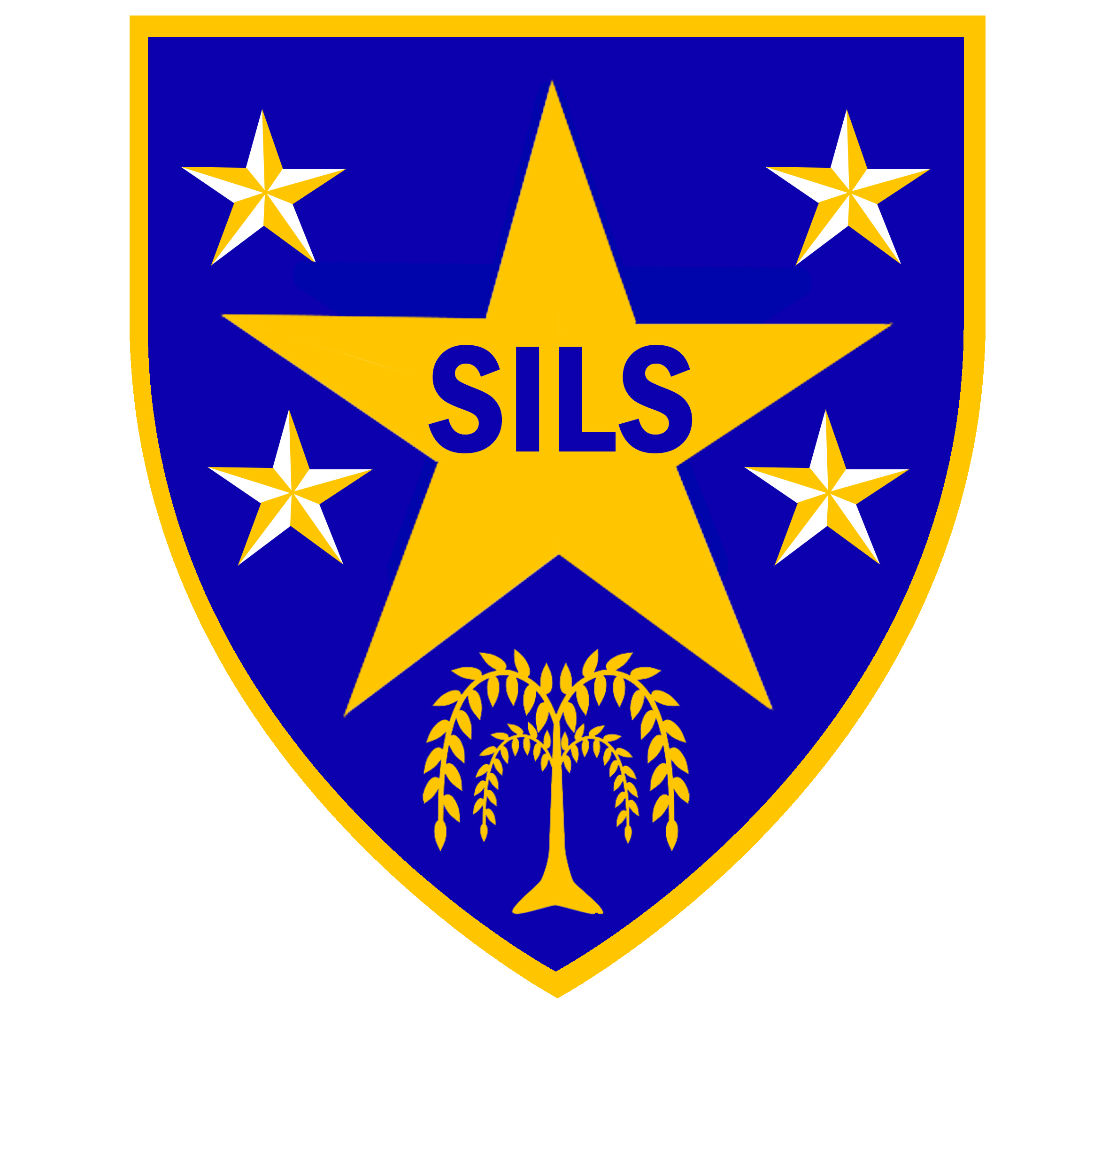

SILS is an alternative education provision for secondary aged learners who are out of mainstream school because of social, emotional, behaviour and / or mental health needs (SEMH).
Every member of the SILS community is valued, and our ideal candidate for this position will have strong experience of motivating and engaging learners who may be disengaged or have additional needs.
We are a ‘Good School’, and our ‘staff work collaboratively to give every student the chance to succeed’ (Ofsted 2018).

The roles
We are looking for an enthusiastic and inspirational language teacher to lead the delivery of an engaging curriculum at our key stage 3 site.
The position will involve the teaching of English Language and Literature at key stage 3, in collaboration with English teachers in post at key stage 4.
We are particularly keen to hear from candidates with track record of successful work with learners with additional needs, and a teacher with experience of improvement strategies designed to raise standards of literacy, language and communication skills across all subjects.

If you think you can make a difference to the lives of our young people and you are willing to work across our two sites, then we would like to hear from you. Please note that informal visits are welcome. To arrange please contact Carol Hepper, Business Manager on 020 7525 1150 or email carol.hepper@southwark.gov.uk
Information about the school and an application form can be obtained from the school's website at www.silsschools.org under Job Vacancies

Closing date: Friday 5th October 2018, 12 noon
Interviews: Week of 8th October 2018

SILS is committed to safeguarding and promoting the welfare of children and young people and expects all staff to share this commitment. An enhanced DBS check is required for all successful applicants.

Southwark Inclusive Learning Service (SILS), 2 Davey Street. London SE15 6LF
 020 75251150  silsschools.org

