Inclusion Officer – KS4  Dates: Apply by 21/11/2019, Job start January 2020  Salary: Hay 8, £29,796 – £33,759 per annum (to be pro rata) - (Negotiable for a suitable candidate)  Location: South London  Contract type: Full time, 5 days per week, term time only  Contract term: Fixed term, one year in the first instance (Negotiable for a suitable candidate) |  | 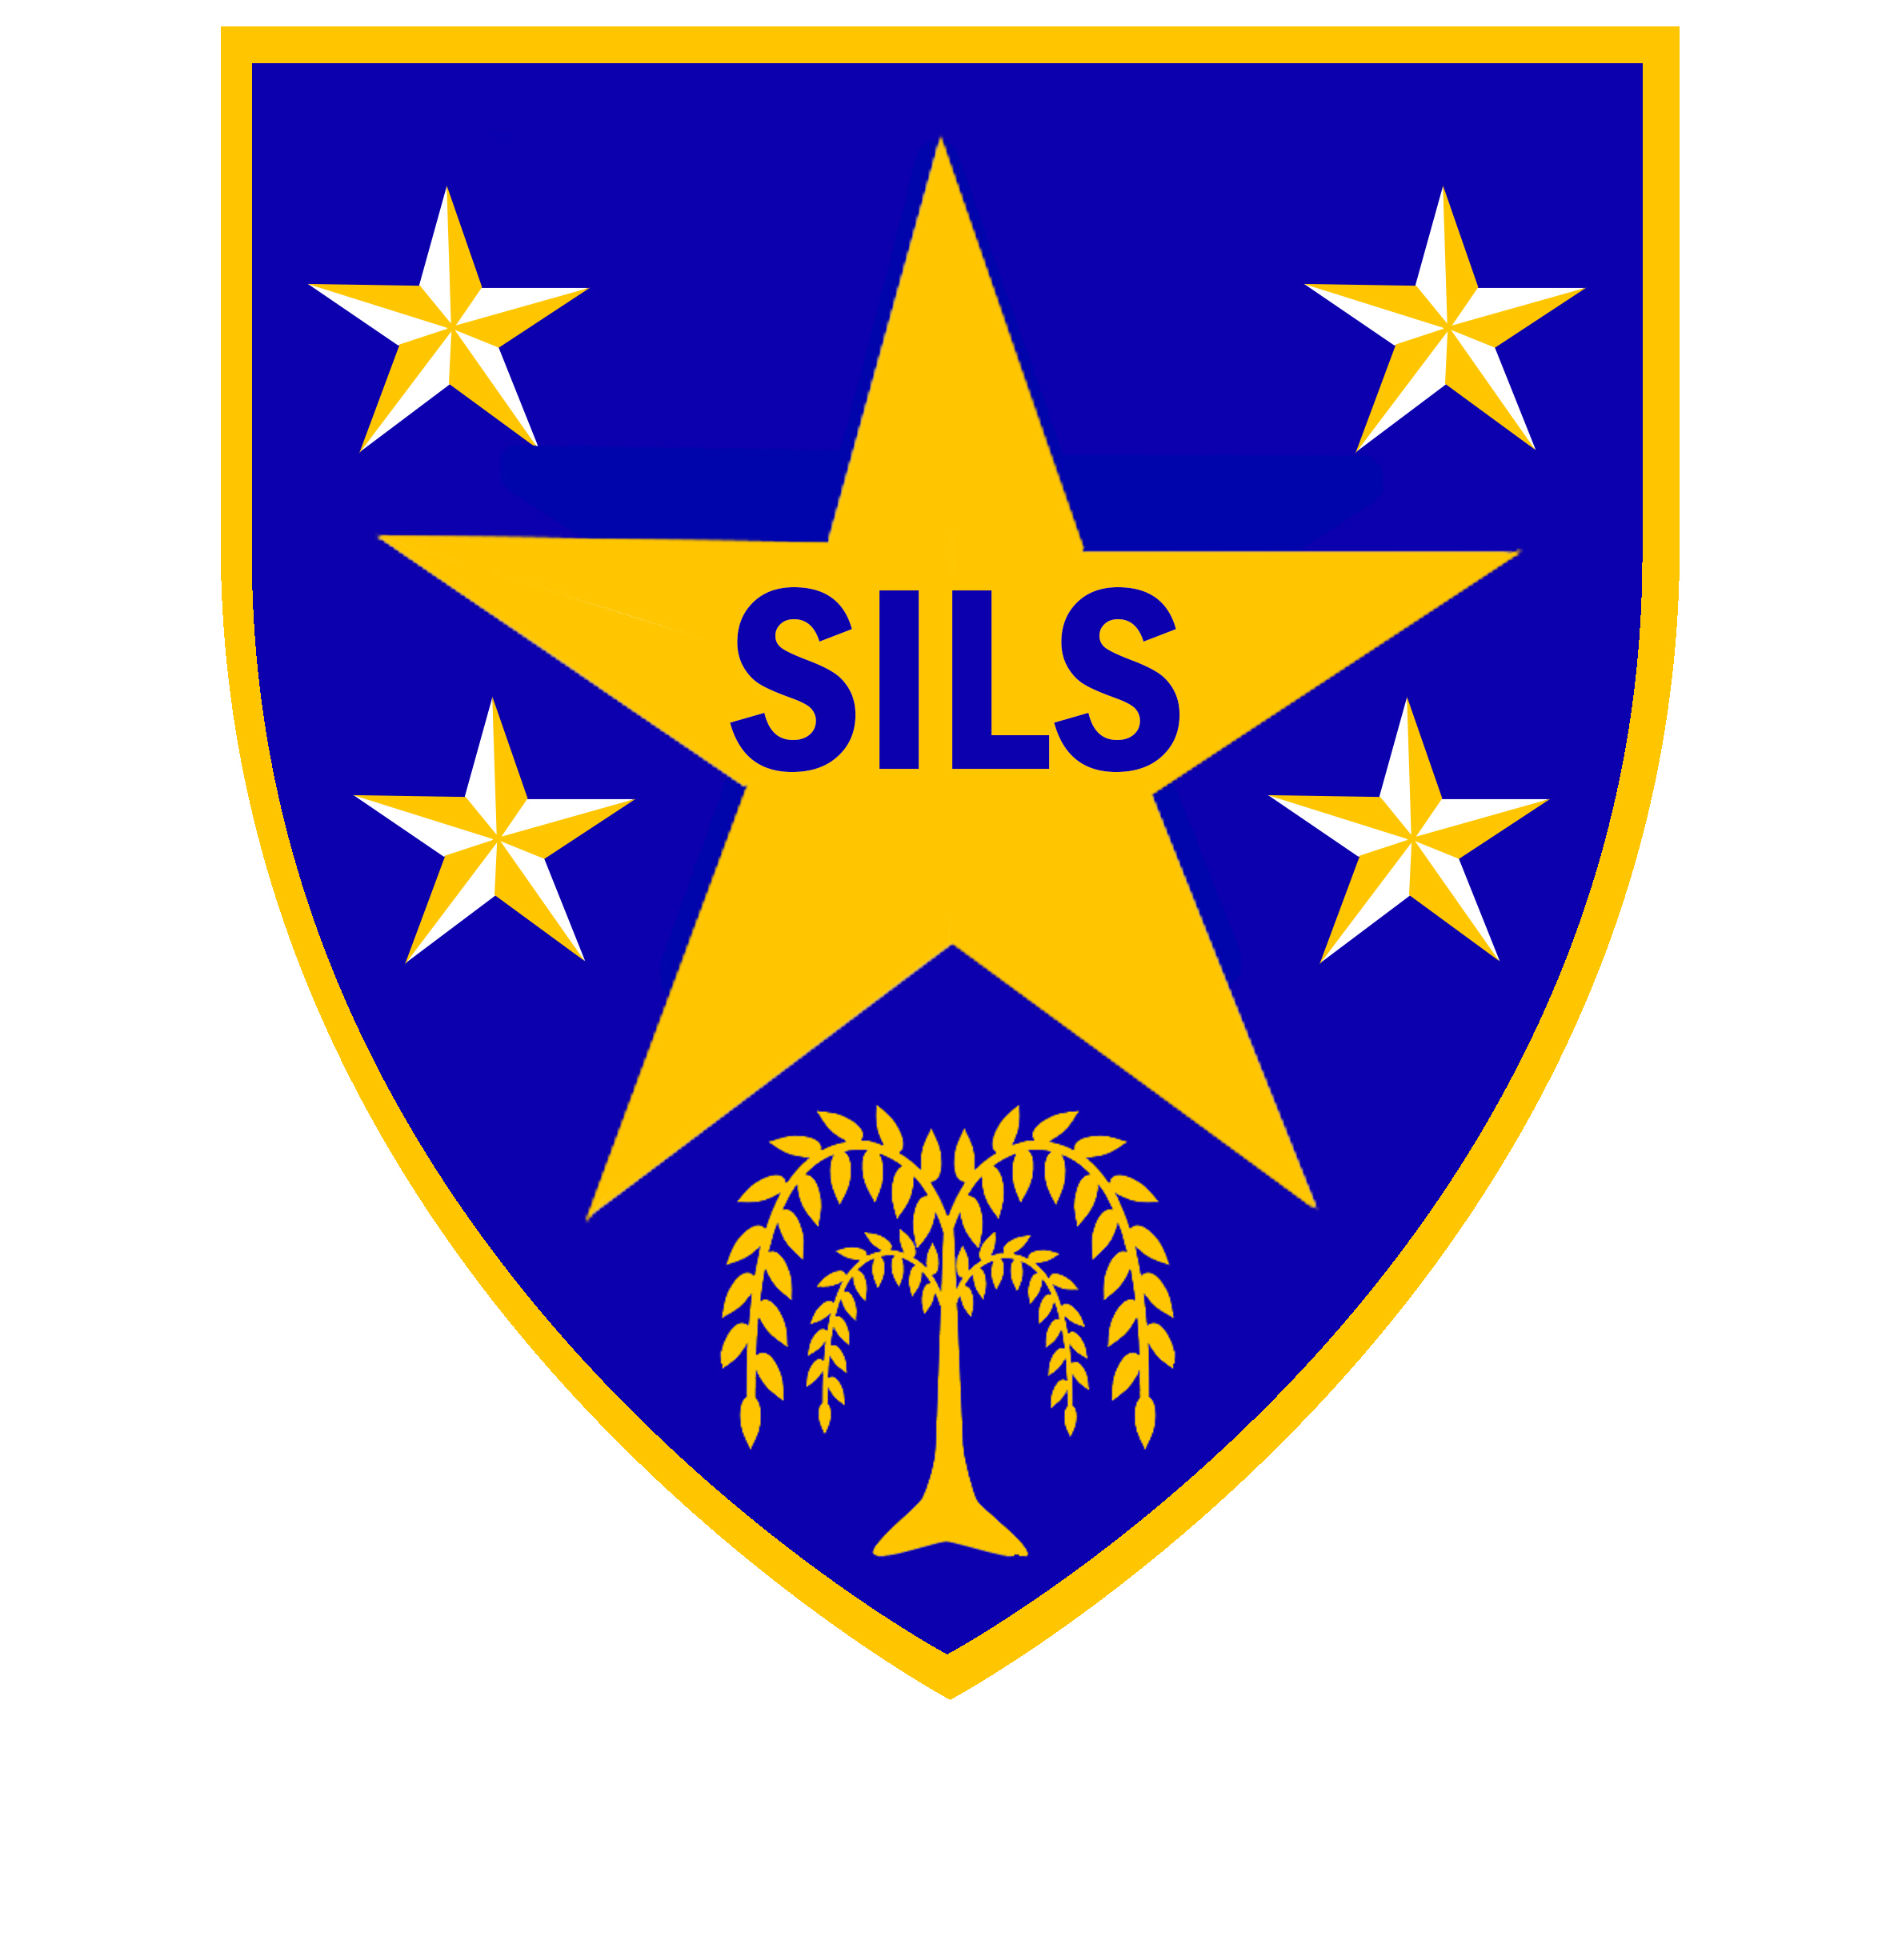
Southwark Inclusive Learning Service (SILS)
SILS is an alternative provision for secondary aged learners who are out of mainstream education due to social, emotional, behaviour and / or mental health needs (SEMH). SILS is a Good School (Ofsted, 2018) with a committed staff team.
The role
We are looking to appoint an enthusiastic and committed individual to act as lead professional for inclusion, student welfare and multi- agency work at KS4.

The successful candidate will need to have:
- Excellent communication and interpersonal skills to engage and motivate our students
- Experience of effective work with secondary aged students, families and professionals
- Evidence of innovative approaches and interventions to address the needs of learners
- Positive and aspirational attitude, to lead, inspire and act as a role model for our students

What we offer:
- Learners with enormous potential
- Focus on raising standards - learners developing into confident resilient young adults
- Supportive environment in which your enthusiasm, commitment and passion in making a difference to the lives of our students will be rewarded

This is an exciting opportunity for the right candidate to join our school and contribute to the culture of aspiration and achievement. If you think you have the necessary skills to make a difference, we would like to hear from you.

Information on the school and an application form can be obtained from the school's website at www.silsschools.org alternatively; you can contact Genevieve Marsh, SILS Business Manager on 02075251668 or email gmarsh@sils.southwark.sch.uk

Closing date: Thursday 21 November 2019, 12 noon
Interview: Week of 25 November 2019

SILS is committed to safeguarding and promoting the welfare of children and young people and expects all staff to share this commitment. An enhanced DBS check is required for all successful applicants.

Southwark Inclusive Learning Service (SILS), 2 Davey Street. London SE15 6LF
 020 75251150  silsschools.org

