Catering Manager KS3  Southwark Inclusive Learning Service (SILS)  Dates: Apply by Monday 29 June 2020, 9a.m.  Starting 1st September 2020  Salary: Hay Grade 5, £23211 to £26298 per annum  Contract type: 30 hours per week TTO + INSET days  Contract term: Permanent  Location: South London | 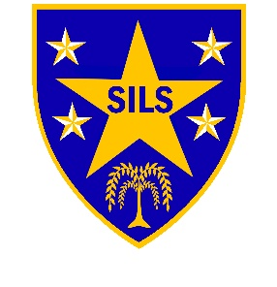

SILS is looking for an exceptional Catering Manager to join our supportive staff team, as we move into new purpose built KS3 building in September.
As a small alternative provision school, the catering manager at KS3 will be producing fresh meals for between 40 – 60 learners and adults daily.
Are you eager and able to:
- Cook the amazing meals for our students and staff
- Educate our students on what a healthy diet looks like and present meals in a way that develops their culinary tastes
- Be creative to offer more options for lunch, and
- Develop and promote exciting catering offer for evening or weekend lettings
If you can fulfil the above, we will like to hear from you.
As catering manager, you will have responsibility for ensuring that the quality of dining is outstanding. You will also have responsibility for preparation and cooking of meals, budgeting and ordering, health and safety and liaison with KS4 staff to develop a good quality catering across the school.
This is a fantastic opportunity to be part of the SILS staff team, working together to take the school forward in its ambition to always achieve the best outcomes for our students.
We are committed to providing first-rate training and development to all of our staff. We have a proven track record of school improvement, offering students an exciting curriculum and opportunities to develop their skills and experience the world of work outside of the classroom.
Interested? Please have a read through the job description and application form which is available on the school's website www.silsschools.org under Job Vacancies, and note that only applications submitted on the school's form will be considered.
Completed forms should be emailed to gmarsh@sils.southwark.sch.uk
Closing date for applications is: 9.00am Monday 29 June 2020
Interviews: Week of 6 July 2020

School address: Southwark Inclusive Learning Service
2 Davey Street, London. SE15 6LF. Tel: 0207 525 1150

SILS is committed to safeguarding and promoting the welfare of children and young people and expects all staff to share this commitment; therefore, the successful applicant will be required to undertake an enhanced Disclosure and Barring Service Check via the DBS.

