Personal Assistant to the Headteacher (part time)  Southwark Inclusive Learning Service (SILS)  Dates: Apply by 12 noon, Monday 9 November 2020  Start date: October 2020 or as soon as possible thereafter  Salary: Hay scale 6 £24,486 to £27,744 pro rata  Location: Southwark, South London  Contract type: Part Time, 4 days per week  Contract term: 1-year fixed term, term time only | 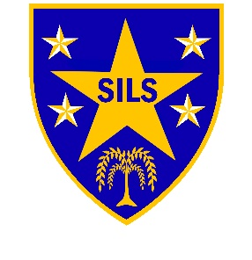

Why choose us?
SILS is an alternative education provision for students excluded from mainstream schools due to learning or social emotional mental health difficulties.
We have consistently been judged to be a ‘Good School’ by Ofsted, and our staff team are committed to the achievement of high standards and improved outcomes for our learners.
The role
We are at an exciting point in our journey and wish to appoint an efficient, flexible and organized Personal Assistant to support the Headteacher. The post would suit a candidate who is committed to working in a school environment with secondary aged learners.
Our ideal candidate will:
- Have outstanding organisational skills and the ability to be flexible
- Have a proven track record in a similar role
- Always maintain confidentiality and a high standard of professionalism
- Have excellent administrative skills both written and orally
- Have attention to detail for data entry and ability to work under pressure
- Have good knowledge of Microsoft Office products
- Have excellent interpersonal skills and the confidence to liaise effectively with all members of our school community: students, parents, staff and professionals
In return, we offer you the opportunity to:
- Join a happy, positive environment where hard work and success is recognised
- Access excellent professional development and support
- Work alongside a dynamic SLT and admin team, who are enthusiastic and focused
- Be part of exciting projects and opportunities ahead of us.
Interested? Do have a read through the job description and person specification which is available on the school's website www.silsschools.org under Job Vacancies. Note that only applications submitted on the school's form will be considered.
Closing date: Monday 9 November 2020, 12.00 noon
Interviews: Week beginning 16 November 2020
Enquiries: Genevieve Marsh, Business Manager on 0207 525 1668, email gmarsh@sils.southwark.sch.uk
Address: SILS, 2 Davey Street, London. SE15 6LF. Tel: 0207 525 1150
SILS is committed to safeguarding and promoting the welfare of children and young people and expects all staff to share this commitment; therefore, the successful applicant will be required to undertake an enhanced Disclosure and Barring Service Check via the DBS.

