Inclusion Officer / Pastoral Leader  Dates: Job start June 2023, or earlier if possible  Salary: £26,361 to £29,867 per annum  Location: South London  Contract type: Full time 5 days per week, term time only  Contract term: Fixed term, one year in first instance |  | 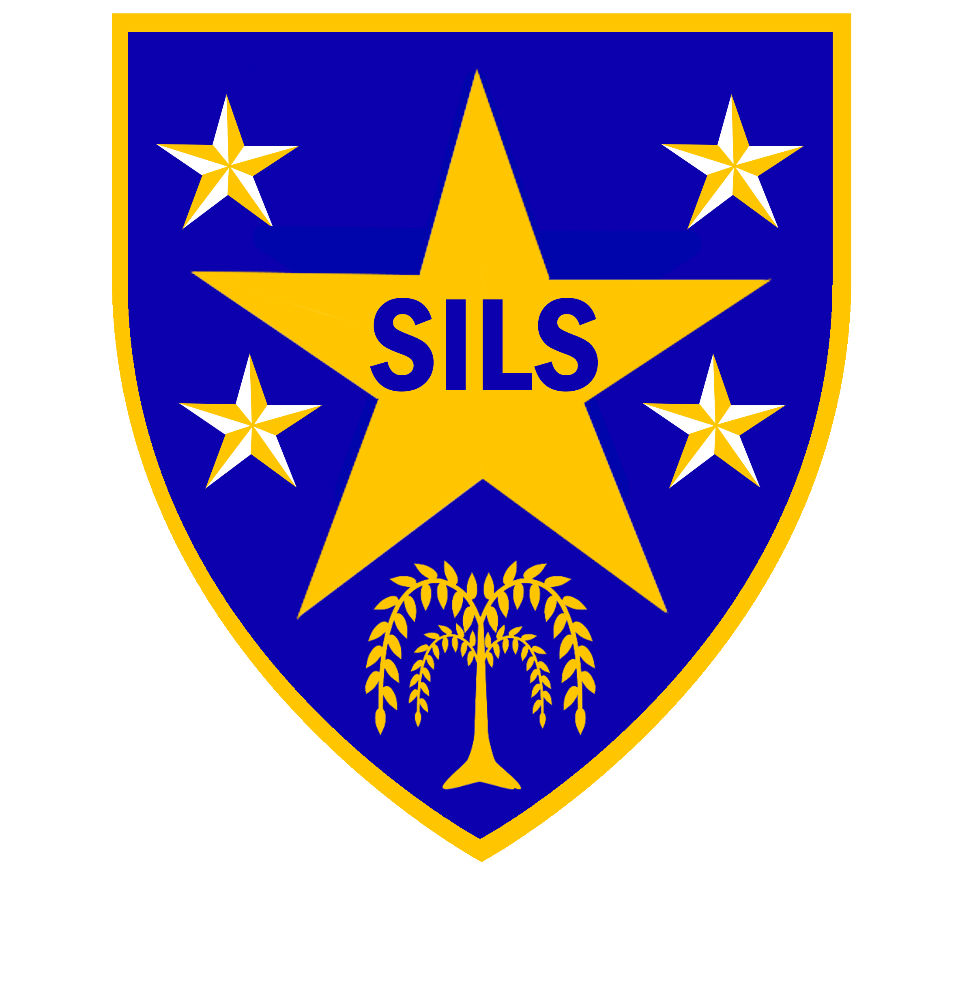
Our School
SILS is an 11- 16 Pupil Referral Unit for children excluded from mainstream schools due to social, emotional, behaviour and / or mental health difficulties (SEMH). We are located on two sites across London Borough of Southwark; and we are a ‘Good School’ (Ofsted, June 2018).

The role
We are seeking to recruit a dynamic, passionate and effective individual to the position of inclusion and pastoral leader at our key stage 4 provision. The postholder will have oversight for a year group and will be responsible for student personal development, wellbeing, attendance and high standards of behaviour.

The successful candidate will need to have excellent communication and interpersonal skills to engage and motivate our students, many of whom have additional needs. The candidate will also need to have a track record of effective work with colleagues, professionals and families. The competencies to successfully deliver PSHE or employability skills will be an advantage.

This is an exciting opportunity for the right candidate to join SILS, and to contribute to our culture of aspiration and achievement. If you have the necessary skills and experience to make a difference, we would like to hear from you.

For further information and an application pack please go to our website www.silsschools.org
Alternatively, please contact Pele Oladitan, school business manager on 0207 5251150, email poladitan@sils.southwark.sch.uk or contact Djedje Agui, Associate Headteacher on 0207 5250370 for an informal discussion.

Closing date: Friday 21 April 2023, 12 noon
Interview: Week of 8 May 2023

SILS is committed to safeguarding and promoting the welfare of children and young people and expects all staff to share this commitment. An enhanced DBS check is required for all successful applicants. Please note that CVs will not be accepted for this position.

Southwark Inclusive Learning Service (SILS)
KS3: 2 Davey Street, SE15 6LF Tel: 0207 525 1150
KS4: Porlock Hall, SE1 3RY. Tel: 0207 525 0370

