Teacher of Maths, Part time  Dates: Job Start 1st September 2024 (or earlier if possible)  Salary: MPS + SEN1  Location: South London  Contract type: Part time (0.6FTE) 3 days / week  Contract term: 1-year fixed term contract | 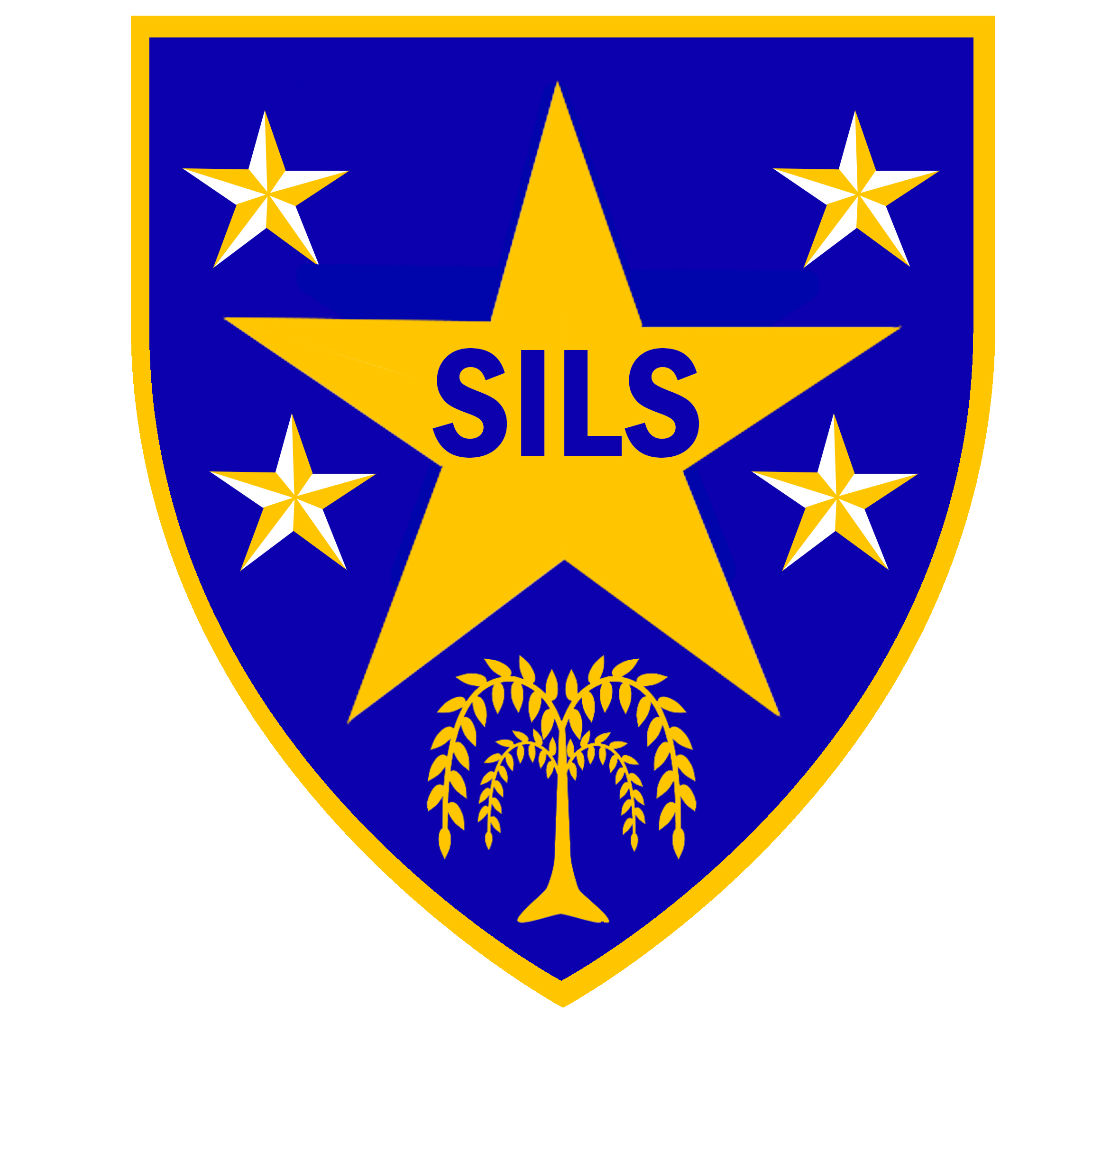
Southwark Inclusive Learning Service (SILS)
Why choose us?
SILS is a pupil referral unit for secondary aged learners that are out of mainstream education due to exclusion or other complex reasons.
SILS continues to be a good school (Ofsted, Jan 2024). ‘Pupils thrive at SILS, because staff have extremely detailed knowledge of each student and have developed strong caring relationships with them’.
The role
We are looking for an enthusiastic and motivated teacher of Mathematics to join our staff team. The successful applicant will work alongside strong subject leaders to design and implement a curriculum that will engage and deliver exceptional outcomes for our key stage 3 learners.

We are keen to hear from early career teachers or those with qualified teacher status, with a record of successful work in mainstream, alternative education or an SEMH setting.

The successful applicant must be committed to the SILS School Values – Growth, Resilience, Excellence, Ambition & Respect, and must be driven by the desire to improve the life chances of our young people.

We offer a supportive environment and we are committed to high quality professional development for our staff. If you share our passion and commitment to developing confident capable young people, then we would like to hear from you. Although the position will be based at key stage 3, applicants must be willing to work across our two school sites.
Informal visits are encouraged. To arrange please contact Pele Oladitan, Business Manager on 020 7525 1150 or email poladitan@sils.southwark.sch.uk
Further information about our school and an application form can be obtained from the school's website at www.silsschools.org under Job Vacancies

Closing date: Monday 15th April 2024, 12 noon
Interviews: Week of 29th April 2024

SILS is committed to safeguarding and promoting the welfare of children and young people and expects all staff to share this commitment. An enhanced DBS check is required for all successful applicants.

Southwark Inclusive Learning Service (SILS), 2 Davey Street. London SE15 6LF
 020 75251150  silsschools.org

