Catering Manager / Cook  Southwark Inclusive Learning Service (SILS)  Dates: Apply by Monday 15th April 2024, to start by 6th May 2024  Salary: Hay 5, Scp 6 - 13, £28,977 to £32,205 pro rata  Location: South London  Contract term: Permanent  Hours: 30 hours per week, term time only (including 5 training days) | 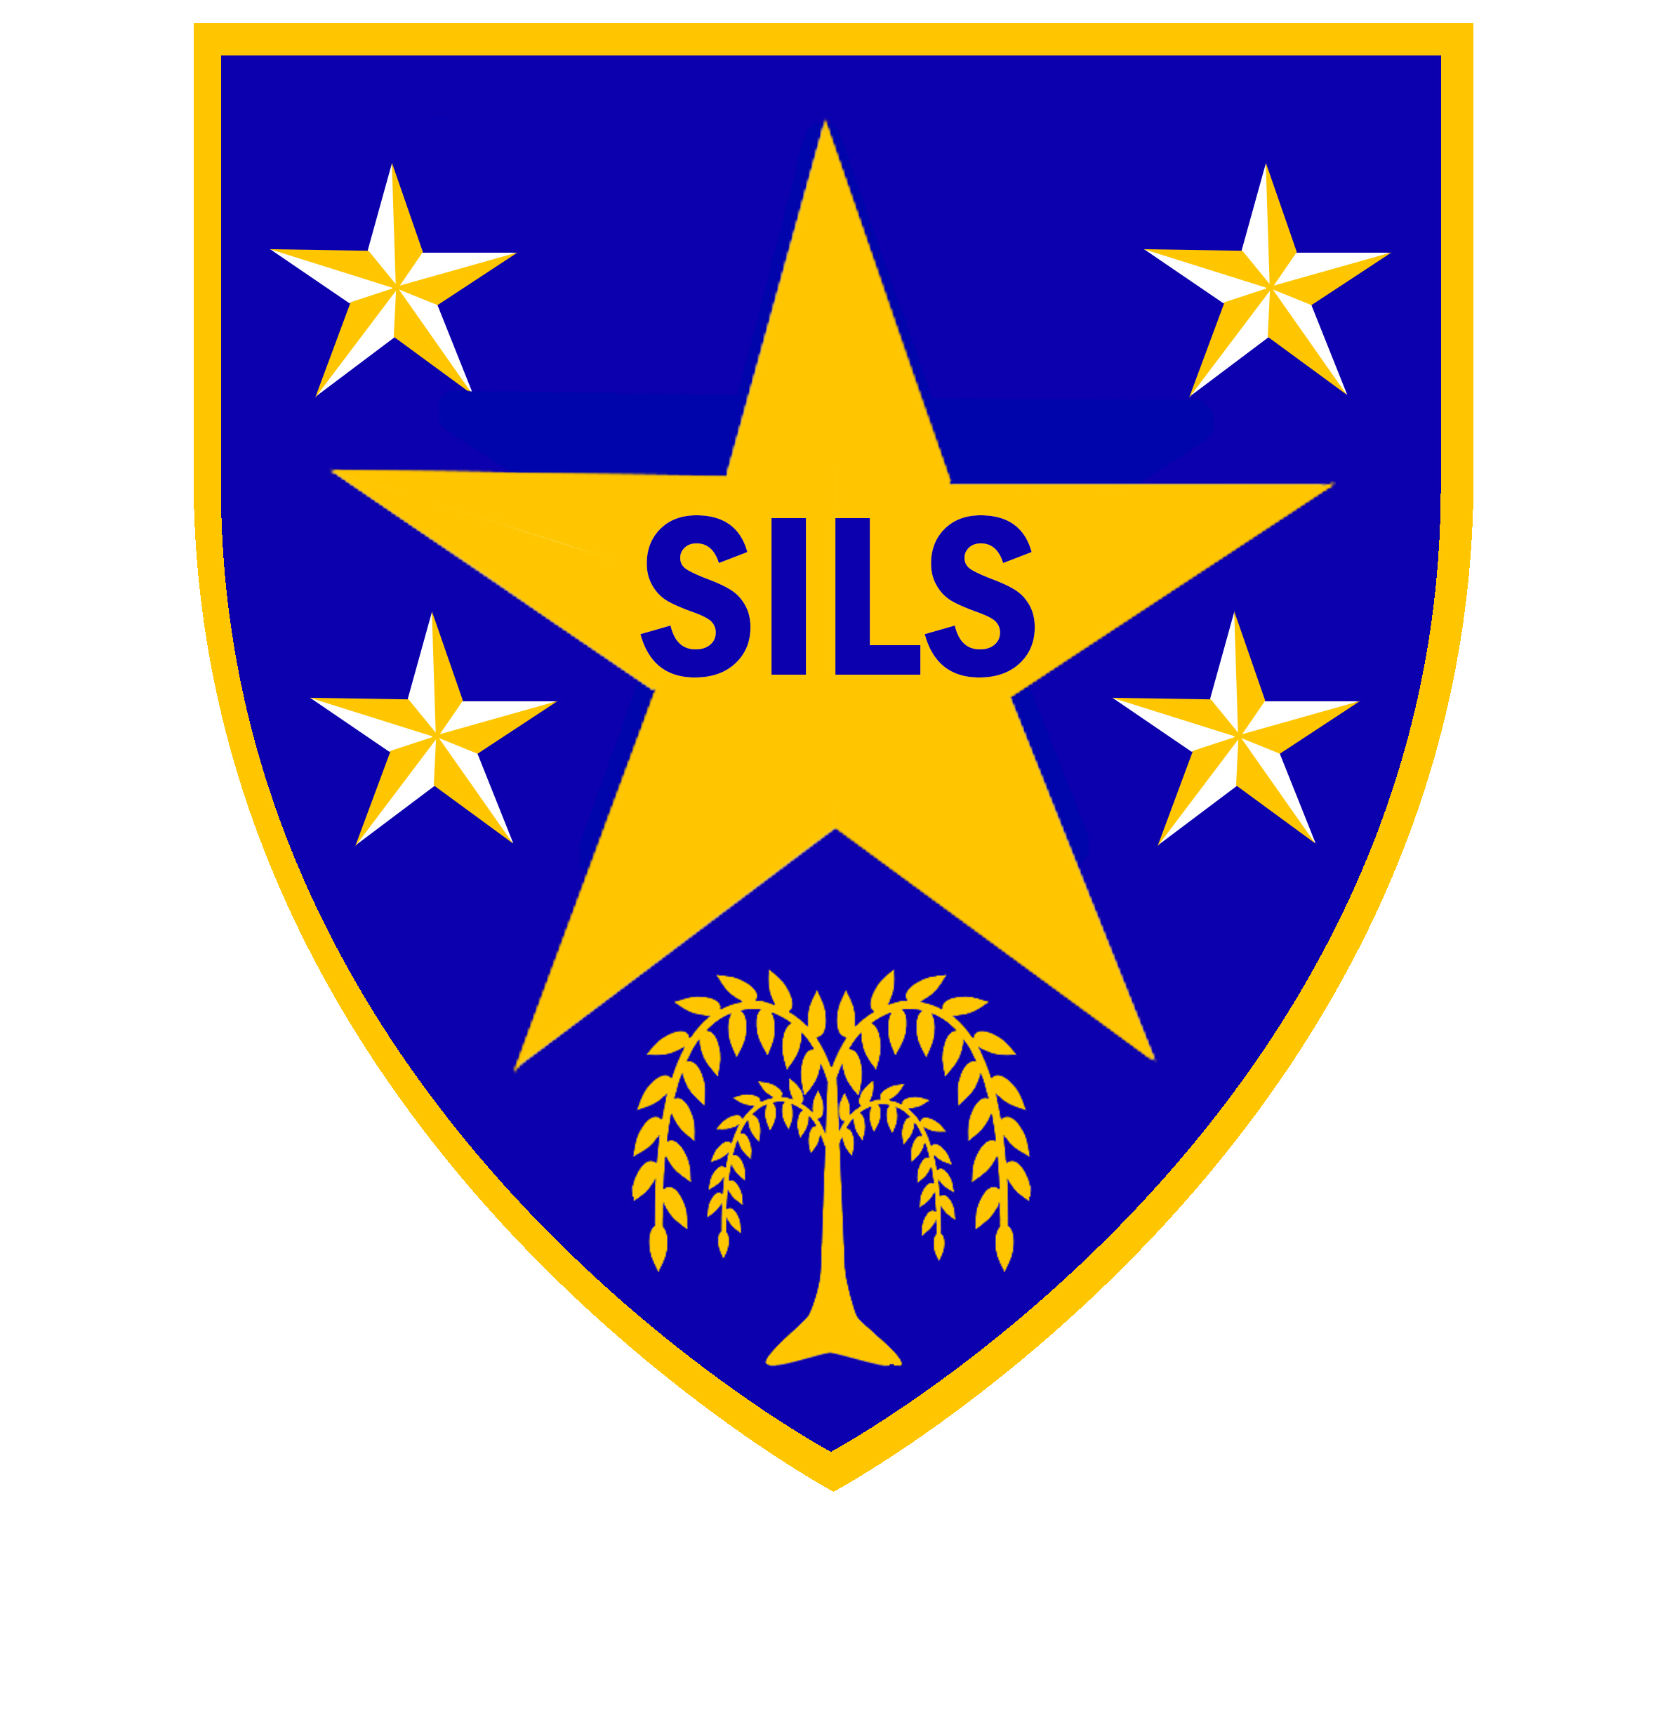

SILS is an alternative education setting for students who have either been excluded or are risk of exclusion from a mainstream school.
SILS continues to be a good school (Ofsted, Jan 2024). ‘Pupils thrive at SILS, because staff have extremely detailed knowledge of each student and have developed strong caring relationships with them’.
The role
We are looking for a catering manager / cook to be based at our key stage 4 site to be responsible for the preparation of meals for our students and staff.
As cook, the duties of the role will include:
- Ordering, preparation and serving of fresh healthy nutritious meals within budget
- Working in accordance with school food standards, allowing for allergen issues, and with adherence to recipes, food preparation standards and portion control
- Ensuring that work within the kitchen and dining area is carried out hygienically and safely within the prevailing legislative framework
The successful candidate will be experienced, motivated, capable of using their initiative; and will have qualifications which might include Level 2 CIEH in Food Hygiene, NVQ Level 2 in Food Preparation & Cooking, or similar / equivalent qualifications. In return, we will provide consultant and in school support, and access to training and continued professional development.
Interested? please have a read through the job description attached, which is also available on our school website www.silsschools.org/vacancies Alternatively, please contact Pele Oladitan, School Business Manager on 0207 5251150, email poladitan@sils.southwark.sch.uk for an informal discussion. Do note that only applications submitted on the school's application form will be considered.

Closing date: Monday 15th April 2024, 12 noon
Interviews: Week of 22nd April 2024

Address: Southwark Inclusive Learning Service
2 Davey Street, London. SE15 6LF (KS3) Tel: 0207 525 1150
Porlock Hall, Porlock Street. London. SE1 3RY

SILS is committed to safeguarding and promoting the welfare of children and young people and expects all staff to share this commitment. An enhanced DBS check is required for all successful applicants.

