Vacancy: Teacher of Health & Social Care  Dates: To start September 2024 (or earlier if possible)  Salary: MPS + SEN1  Location: South London  Contract type: Full Time  Contract term: 1-year Fixed Term contract | 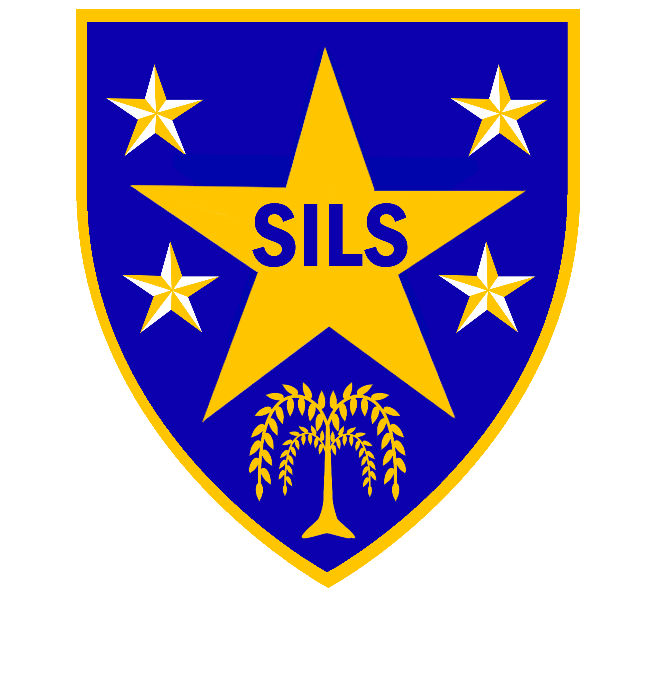

SILS is seeking to appoint an enthusiastic and innovative Food Technology Teacher with the ability to teach a second subject; Food technology is desirable and the experience to teach across key stages 3 and 4, at our PRU in South London.
SILS continues to be a good school (Ofsted, Jan 2024). ‘Pupils thrive at SILS, because staff have extremely detailed knowledge of each student and have developed strong caring relationships with them’.
We are particularly keen to hear from candidates with a track record of successful work with learners with additional or SEMH needs. We also wish to hear from applicants that can offer Textiles or Health and Social Care as a second subject.
In addition to successful experience from a mainstream school or alternative provision, our ideal candidate will:
- be able to inspire, motivate and engage reluctant learners
- be a confident classroom practitioner, with record of high-quality teaching & learning
- have passion for pupil progress, and record of achieving accredited qualifications at KS3 & 4
- be able to work independently and with initiative
- Able to manage the dynamics of a changing / mobile cohort of learners
- have a positive outlook and be committed to teamwork
If you think you can make a difference to the lives of our young people and you are willing to work across our two sites, then we would like to hear from you.
Please note that informal visits are welcome. To arrange, please contact Pele Oladitan, School Business Manager on 020 7525 1150 or email poladitan@sils.southwark.sch.uk
Information about our school can be obtained from the school’s website at www.sils.southwark.org
Closing date: Friday 10th May 2024, 12 noon
Interviews: Week commencing 20th May 2024
SILS is committed to safeguarding and promoting the welfare of children and young people and expects all staff to share this commitment. An enhanced DBS check is required for all successful applicants.

Southwark Inclusive Learning Service (SILS), 2 Davey Street. London SE15 6LF
 020 75251150  silsschools.org

